RARE PLANTS OF CALIFORNIA IN GREATER SAN QUINTÍN,
BAJA CALIFORNIA, MEXICO

Sula E. Vanderplank

Rancho Santa Ana Botanic Garden, 1500 North College Avenue, Claremont, California 91711
(sula.vanderplank@gmail.com)

ABSTRACT

The southern part of the California Floristic Province that lies in the northwestern portion of the state of Baja California in Mexico shares many species with southern California in the US, and indeed serves as a major repository for a large number of our rare and endangered species. Greater San Quintín is home to some pristine coastal environments such as dunes, marshes, and coastal sage scrub that harbor some endemic species, along with several species currently listed by the California Native Plant Society as rare, threatened, or endangered in the state of California. Recent floristic research in the San Quintín area has documented 22 CNPS-listed species so far. Effective conservation of CNPS-listed taxa that occur in Baja California would benefit greatly from efforts to maintain pollinator corridors and viable population sizes. Coastal species are particularly at risk since rapid development of the coastal region of northwestern Baja California poses a serious threat to many of these populations. A list of the rare and endemic species of the California Floristic Province in Baja California would greatly further bi-national conservation efforts in this region, as would increased research on rare plant populations in Baja California and broad-scale habitat conservation. Cross-border conservation plans will be the most effective (and therefore most cost-effective) mechanisms for conserving shared endangered species.

Resumen

El Area sureña de la provincia florística de California que se encuentra en el norte del estado de Baja California en México comparte muchas especies con el sur de California de EUA, y funciona como uno de los mayores depósitos para un gran numero de nuestras especies raras y en peligro. La bahía de San Quintín es domicilio a áreas naturales no-perturbadas en la costa, como dunas, marismas, y matorral costero, que guardan algunas especies únicas, y muchas especies actualmente listadas por el California Native Plant Society como en peligro en el estado de California. Investigaciones recientes en el área de San Quintín han documentado 22 especies listadas hasta la fecha. Un plan efectivo de conservación para las plantas listadas por el CNPS que ocurren en Baja California tendría enormes beneficios en los esfuerzos de mantener corredores de polinización y tamaños de poblaciones lo suficientemente grandes para ser viables. Las especies costales estan en mas peligro a causa del desarrollo rápido del área costal en el noroeste de Baja California que pose una amenaza a muchas de estas poblaciones. Un listado de las plantas raras y endémicas de la provincia florística de California en Baja California, un incremento en el numero de investigaciones sobre las plantas raras de Baja California, y conservación del habitat, lograran los esfuerzos de conservación binacional en esta región. Los proyectos de conservación en ambos lados de la frontera van a ser los mecanismos más efectivos (y más barato) para conservar las especies compartidas.

Key words: Baja California, California, conservation, cross-border strategies, rare plants, San Quintín, San Martín.

Introduction

The California Floristic Province (CFP) encompasses more than 70% of the state of California, but also extends into Oregon to the north, just barely into Nevada to the east, and into Baja California, Mexico, to the south. The CFP has been recognized by Conservation International as a global biodiversity hotspot and is home to about 3488 plant species, 2124 of which (60%) are endemic to the floristic province (Conservation International 2007a). Unfortunately, it was recently estimated that, owing to human activities, less than 25% of the area originally occupied by native vegetation in the CFP remains undisturbed today (Conservation International 2007b).
The Baja California peninsula is noted as an area of exceptional diversity that is in need of extended protection to more areas (Riemann and Ezcurra 2005). At present, more than 4000 plant species have been documented from the peninsula, about 30% of which are endemic (The Flora of Baja California 2006). On the Baja California peninsula, the CFP is generally agreed to extend approximately 185 mi S to the area around El Rosario (Howell 1957; Thorne 1993). Vegetation studies show that the transitional zone between 30–31° N latitude has the greatest floristic biodiversity on the peninsula and transitional vegetation associations that occur there
have the highest Endemic Community Values (ECVs) (Peinado et al. 1995a).
A number of plants that are threatened north of the border are notable components of the floristic diversity of the CFP south of the US/Mexico border. The CFP in Baja California is effectively serving as a refuge for a number of plants that are listed as threatened or endangered in California by the California Native Plant Society (CNPS). Therefore, knowledge of the plant life of northwestern Baja California may be critical to the long-term well being of California’s endangered flora. More generally, detailed floristic studies in this region are important to our understanding of plant diversity and distribution. This knowledge is necessary to plan and carry out effective conservation measures, both for individual species and for the ecosystems on which they rely.
In 2005, I began a floristic study of an area near the southern boundary of the CFP in Baja California. This project benefited from a grant from the CNPS in 2007 and constitutes my master’s thesis at Rancho Santa Ana Botanic Garden/Claremont Graduate University. This article introduces my study area, shares some of my findings, and highlights the importance of my study for the conservation prospects for our native California flora.

The Greater San Quintín Area

The town of San Quintín lies on the Pacific Coast of Baja California, ca. 160 miles south of the US/Mexico border. The study area includes the San Quintín volcanic field and encompasses 140 mi². It is delimited on the north by the Santo Domingo River, on the east by the Transpeninsular Highway, and by the Arroyo El Socorro to the south. The area extends to the west to include the island of San Martín, which is just a little over 1 mi² (1.6 km²) in area. There are eleven cinder-cones (up to 853 ft elev) in close proximity to the bays; the westernmost of these is Isla San Martín, which sits three mi offshore.
There are also three river drainages in the study area and thus some riparian habitat. The major habitats of Greater San Quintín are along the coast and include coastal sage scrub, salt marshes, and almost 30 mi of sand dunes. There are three large, shallow bays (<40% exposed at low tide), surrounded by a complex, heterogeneous salt marsh that has been considered the most significant in its ecoregion (West 2000). The bays are a seasonal home to perhaps the largest population of Brandt geese in the world. The excellent water quality supports a significant oyster production facility with 21 companies farming inside the 730 licensed hectares (in the 1980s production exceeded 900 tons) (García-Esquivel et al. 2004). More recently the shallow bays became home to a small pod of gray whales that apparently have foregone the long journey north and stay year around in these rich feeding waters. Since 2005, I have made numerous trips to this area, collecting specimens to document the flora and looking at the distribution of perennial species across the greater area.
The area is rich in natural resources beyond marine life: the volcanoes are lucrative sources of rock for extraction, the beaches provide potato-sized rocks that are popular for landscaping in the US, the rivers support large-scale gravel extraction, and the hypersaline lagoons support a booming salt extraction industry. The whole area is a patchwork of native vegetation and intensive agriculture (both active and abandoned), as well as bordered by small towns that are merging as they continue to grow. The recent boom in development along the Pacific Coast, in particular, from Ensenada to San Quintín, has resulted in extreme pressure on the coastal strip of the California Floristic Province in Baja California. At this time, much of the study area remains intact, but intensive agriculture and the rapid pace of development threaten habitat loss for all the native vegetation of Greater San Quintín. Other pressures on the native vegetation, which are common in almost every habitat, include colonization by exotic plants, livestock grazing, and trash dumping.
The focus of this paper is the plants in this region that are rare in California; however, Greater San Quintín has other patterns of rarity and is the only home of two plant species. One of these is Chenopodium flabellifolium Standl. (Cheno-podiaceae), a small herb that is endemic to Isla San Martín; it has a distinctive scent and soft gray leaves. Also found on the island, but endemic to a larger area including the adjacent coast and slopes of the extinct volcanoes, is Dudleya anthonyi Rose (Crassulaceae), a large white dudleya that is related to D. pulverulenta (Nutt.) Britton & Rose. Greater San Quintín is home to many taxa that are endemic to the Baja California peninsula but are not restricted to the CFP portion of Baja. Among these are the monotypic genus Harfordia (H. macroptera (Greene) Reveal) (Polygonaceae) and a number of other species including Amauria rotundifolia Benth. (Asteraceae), Atriplex julacea S.Watson (Chenopodiaceae), and Solanum palmeri Vasey & Rose (Solanaceae). Some Baja California endemics are further restricted to just the CFP portion of the peninsula, e.g., Aesculus parryi A.Gray (Hippocastanaceae), Ferocactus fordii (Orcutt) Britton & Rose, Mammillaria louisae G.E.Linds. (Cactaceae), Phacelia ixiodes A.Gray (Hydrophyllaceae), and Ribes tortuosum Benth. (Grossulariaceae).

Plant Protection in Mexico

There are fewer legal protection mechanisms for plants in Mexico than in the US in general and in California in particular. International trade of endangered species is covered under the Convention on International Trade in Endangered Species (CITES); however, in situ populations are only protected by their location within certain Áreas Naturales Protegidas [Natural Protected Areas] (ANPs) or by their presence on the government list of protected species. Only two species reported from Greater San Quintín are listed by the NOM-059-ECOL-2001 for environmental protection of the native species and wild flora of Mexico: Lophocereus schottii (Engelm.) Britton & Rose and Cylindropuntia californica subsp. rosarica (G.E.Linds.) Rebman. Both are Mexican cacti with L. schottii being more abundant in the Sonoran Desert of the mainland.

California Rare Plants in San Quintín

As noted above and listed in Table 1, a number of species (22) that are threatened and endangered north of the border also occur in Baja California. As I continue to document the flora of San Quintín, this list is growing.
Cordylanthus maritimus subsp. maritimus, salt marsh bird’s beak, (Fig. 1, 2) is listed by both the US federal government and by CNPS (List 1B.2) and has very narrow habitat requirements in that these plants need both fresh and salt water for germination and survival (U.S. Fish and Wildlife Service 1984). This plant is hemi-parasitic and thus also requires the presence of one of its host plants. Despite such complex needs, after the abundant winter rainfall of 2008, this plant could be seen by the tens of thousands in several of the salt marshes surrounding the shallow bays of the volcanic field. Especially large numbers could be seen on Punta Azufre—the east-west peninsula that juts out into the southern portion of the bay; here the plants parasitize Distichlis littoralis (Engelm.) H.L.Bell & Columbus. It is quite likely that the salt marsh birds’ beak will not be seen for periods of several years as the environmental conditions vary and fresh water levels drop below the necessary amount needed for germination. Rosa minutifolia (Fig. 3) is listed by the state of California, but its natural occurrence on Otay Mesa has been extirpated (California Natural Diversity Data Base 2007) and it is now only known from cultivated and transplanted populations. In Greater San Quintín it does not grow on the volcanic areas but is found on clay soils to the north. The area is largely ploughed now but several plants remain in dense thickets on the steep slopes of the Santa Maria escarpment. Plants of this species are still more abundant to the north in the Colonet to San Telmo region.
The CNPS 1B.1 listed species in San Quintín (Dithyrea maritima and Lotus nuttallianus) are restricted to narrow coastal habitats: D. maritima occurs only on young sand dunes, and L. nuttallianus is found along the coast in washes and coastal sage scrub. Although a single population may have many individuals, the habitat requirements are so restrictive that the plants are likely to remain rare. Similarly, many of the List 1B.2 species are also restricted to the coastal vegetation types that are so heavily threatened, e.g., Suaeda esteroa (salt marsh) and Atriplex pacifica (coastal slopes). Aphanisma blitoides (coastal sage scrub) also thrives on the volcanic slopes of the bay during wet springs. Nemacaulis denudata (Fig. 4) remains in large numbers on the miles of pristine dunes, especially to the south of the bay. Some species, in contrast, seem to be consistently rare in the areas where they occur regardless of recent weather conditions. Adolphia californica (Rhamnaceae) is only known from one individual in Greater San Quintín.
Several species share an ‘island disjunct’ pattern: these occur in California only on the California Channel Islands, but are found further south on the mainland in Baja California, e.g., Ribes viburnifolium A.Gray (Grossulariaceae), Quercus tomentella Engelm. (Fagaceae). It is thought that this distribution pattern is related to weather patterns influenced by ocean currents. Salvia brandegeei (Fig. 5) shares this distribution pattern: in California, it is known only from Santa Rosa Island, but a few populations are also known on the mainland of Baja California. Recently, some friends and I found this plant near the bay of San Quintín. The newly discovered population of ca. 130 individuals grows on the inland side of one of the larger volcanic cones where it co-occurs with other CNPS listed plants including Nemacaulis denudata (Polygonaceae) and Euphorbia misera (Euphorbiaceae). Lamentably, the plants here are effected directly by local mining activities. Coreopsis maritina (Fig. 6) is known in California from the heavily impacted coast of San Diego County but is more abundant on the coastal bluffs of Baja California at this time. In San Quintín, Coreopsis maritima is on the southern edge of its range and appears in small

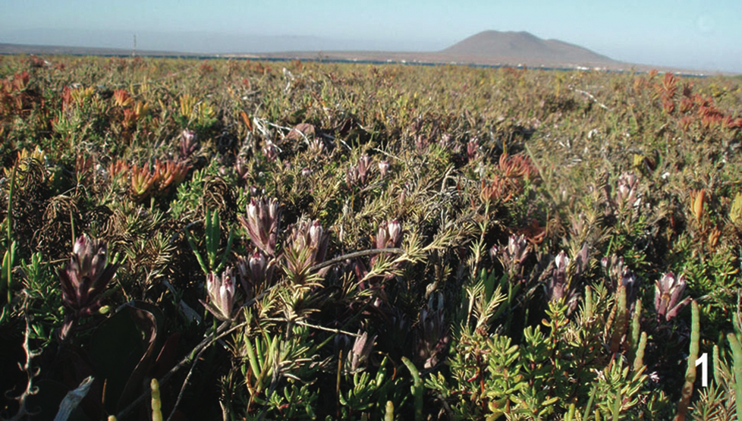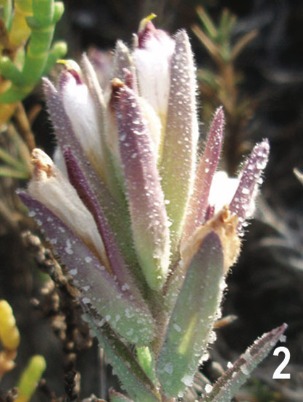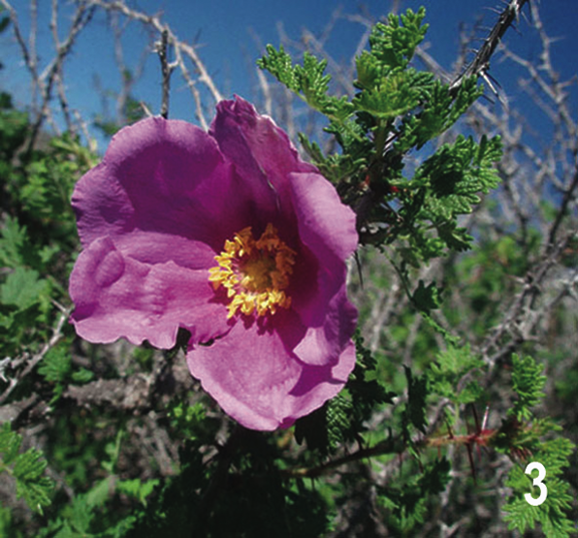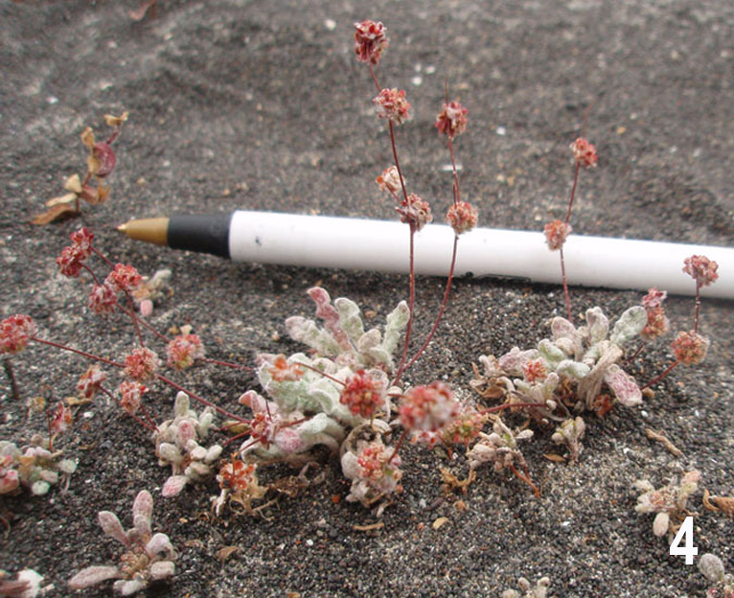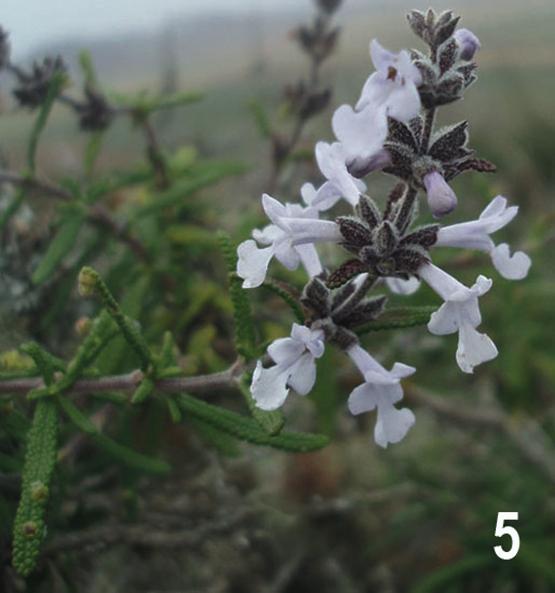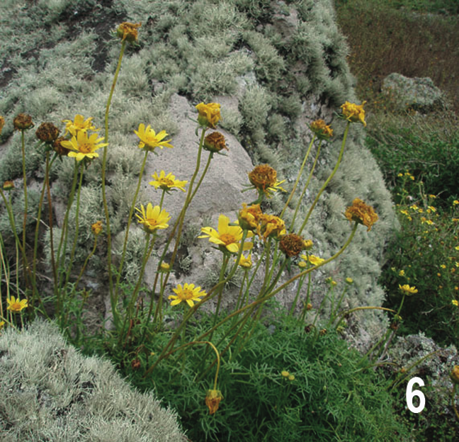

Fig. 1–6. Images of CNPS-listed plants in San Quintín.—1–2. Cordylanthus maritimus subsp. maritimus.—3. Rosa minutifolia.—4. Nemacaulis denudata.—5. Salvia brandegeei.—6. Coreopsis maritima.

numbers on the coastal cinder-cones, including Isla San Martín.
Large populations may be key to preserving genetic diversity and luckily San Quintín is still home to sizeable populations of many CNPS-listed plants (see Table 2). Many of the coastal plants that are on the CNPS watch list (List 4; e.g., Abronia maritima, Batis maritima) persist here and further south (Felger 2000) in very large numbers. Maintaining corridors of connectivity between dwindling California populations and the large populations to the south will be important for gene flow, seed set, and population viability in these species.

Significance of Plants of San Quintín for Conservation of the CFP flora (conservation recommendations)

All the plants in Table 1 that are on CNPS List 2 are more abundant in Baja California than California. Working to conserve habitats south of the border seems an effective way for CNPS to achieve its conservation goals for several species. If populations outside the state are lost to development they will become List 1B taxa. The plants currently on List 4 may move to List 2 if development and habitat destruction continues within California, and thus the large intact populations to the south may be of increasing conservation significance. Strategies to improve the conservation of rare plants that California shares with Baja California include habitat conservation south of the border, increased field studies of these plants in Baja California, and increased cross-border planning for long-term conservation.
Whereas many California rare plants are heterogeneous in their life history traits, their occurrences in Baja California are each highly significant to their conservation. In fact, our knowledge of the habit and life history of these species is greatly enhanced by studying them in areas where they are more abundant (Baja California). This sort of information is critical to the development of effective species conservation plans. These Baja California occurrences also serve as genetic reserves that are crucial to maintaining genetic diversity to avoid “genetic bottlenecks” caused by inbreeding. These Baja California populations also serve an important function as model systems for the

Table 1. CNPS-listed plants recently documented in Greater San Quintín listed alphabetically by rank (with the exception that state and federal listings are noted first).

Taxon | Family | CNPS rank | State-listing date | Federal-listing date
Cordylanthus maritimus Benth. subsp. maritimus | Scrophulariaceae | 1B.2 | 1970 | 1978
Rosa minutifolia Engelm. | Rosaceae | 1B.2 | 1989 | –
Dithyrea maritima (Davidson) Davidson | Brassicaceae | 1B.1 | – | –
Lotus nuttallianus Greene | Fabaceae | 1B.1 | – | –
Aphanisma blitoides Nutt. ex Moq. in DC. | Chenopodiaceae | 1B.2 | – | –
Atriplex pacifica A.Nelson | Amaranthaceae | 1B.2 | – | –
Isocoma menziesii var. decumbens (Greene) G.L.Nesom | Asteraceae | 1B.2 | – | –
Nemacaulis denudata Nutt. | Polygonaceae | 1B.2 | – | –
Salvia brandegeei Munz | Lamiaceae | 1B.2 | – | –
Suaeda esteroa Ferren & Whitmore | Amaranthaceae | 1B.2 | – | –
Adolphia californica S.Watson | Rhamnaceae | 2.1 | – | –
Agave shawii Engelm. subsp. shawii | Agavaceae | 2.1 | – | –
Ambrosia chenopodiifolia (Benth.) W.W.Payne | Asteraceae | 2.1 | – | –
Frankenia palmeri S.Watson | Frankeniaceae | 2.1 | – | –
Bergerocactus emoryi (Engelm.) Britton & Rose | Cactaceae | 2.2 | – | –
Coreopsis maritima (Nutt.) Hook.f. (Fig. 6) | Asteraceae | 2.2 | – | –
Euphorbia misera Benth. | Euphorbiaceae | 2.2 | – | –
Camissonia lewisii P.H.Raven | Onagraceae | 3.3 | – | –
Abronia maritima Nutt. ex S.Watson | Nyctaginaceae | 4.2 | – | –
Juncus acutus subsp. leopoldii (Parl.) Snogerup | Juncaceae | 4.2 | – | –
Lycium californicum Nutt. | Solanaceae | 4.2 | – | –
Viguiera laciniata A.Gray | Asteraceae | 4.2 | – | –
Batis maritima L. | Bataceae | Considered, but rejected | – | –

maintenance and restoration of California habitats that have already been badly damaged. Coastal systems in particular have been extensively and heavily impacted in California and the intact and diverse coastal systems to the south serve as strong indicators of the ecosystem function and diversity that we should strive to restore along California’s coastline.

Communities

Just as a number of species that occur in the Greater San Quintín area are of special interest from the perspective of conservation in general and of the California flora in particular, so too are some of the plant communities in which these species occur. As noted earlier, the transitional vegetation associations
between 30–31° N latitude have the highest Endemic Community Values in Baja California (Peinado et al. 1995a). In San Quintín these associations include coastal sage scrub community associations of Bergerocactus emoryi–Agave shawii, a more tropical desert vegetation type that is at its northern limit in the Mediterranean climate zone in the Greater San Quintin area (Peinado et al. 1995a). Similarly, the vegetation type dominated by Rosa minutifolia–Aesculus parryi A.Gray occurs mainly in wetter regions to the north. In saline soils that are transitional between salt marsh and upland habitats, Atriplex julacea S.Watson–Frankenia palmeri S.Watson communities are found (Peinado et al. 1995b). In these communities it is the combination of restricted plants dominating the landscape that results in a vegetation type that is even more rare and unusual than the plants themselves.

Table 2. Habitat and abundance of CNPS taxa in the Greater San Quintín region listed alphabetically by species.

Plant | Common name | Habitat | Notes on abundance
Abronia maritima | sand verbena | young dunes | abundant
Adolphia californica | California spinebush | stabilized dunes /coastal sage | rare
Agave shawii subsp. shawii | Shaw’s agave | coastal sage | scarce
Ambrosia chenopodiifolia | goosefoot bursage | coastal sage | abundant
Aphanisma blitoides | San Diego coastal creeper | coastal sage | abundant in wet years
Atriplex pacifica | south coast saltscale | coastal slopes | infrequent
Batis maritima | fleshy-leaved saltwort | marsh | frequent
Bergerocactus emoryi | golden cereus | coastal sage | occasional
Camissonia lewisii | Lewis’s evening primrose | dunes | abundant in wet years
Cordylanthus maritimus | salt marsh birds beak | marsh | abundant in wet years
Coreopsis maritima | sea dahlia | coastal sage | occasional
Dithyrea maritima | beach spectacle pod | dunes | locally abundant
Euphorbia misera | cliff spurge | coastal sage | abundant
Frankenia palmeri | Palmer’s frankenia | marsh | abundant
Isocoma menziesii var. decumbens | decumbent goldenbush | coastal sage | rare
Juncus acutus subsp. leopoldii | spiny rush | riparian areas | locally common
Lotus nuttallianus | Nuttall’s lotus | dunes | uncommon
Lycium californicum | California boxthorn | stabilized dunes / coastal sage | abundant
Nemacaulis denudata | coast wooly-heads | dunes | abundant
Rosa minutifolia | baja rose | coastal sage | scarce (one patch)
Salvia brandegeei | Brandegee’s sage | coastal sage | scarce (one patch)
Suaeda esteroa | estuary seablight | marsh | uncommon
Viguiera laciniata | San Diego sunflower | coastal sage | scarce

The need for more research on the flora of Baja California

Although there have been several excellent contributions to our understanding of the flora of Baja California, much remains to be learned. San Quintín is a relatively well-botanized area of the Baja Peninsula; notably Thorne (1989) published a checklist of plants known from the area. The number of additional plants documented during the present, more intensive and extensive floristic study exemplifies how much more there is to discover about plants, their distributions, and the communities in which they occur. There remains the possibility of encountering many little-known taxa in the least-explored expanses of the Baja California peninsula that remain. This makes the region of even greater conservation importance since there are likely to be substantial numbers of species of conservation concern within localities we have yet to visit. Salvia brandegeei is an example of a plant known from very few populations that may have a larger range than we realize, but has small populations across the range. Despite notable interest in these plants in California, there is considerably less research or documentation being done on these same taxa south of the US border. The Flora of Baja California (2006) project at the San Diego Natural History Museum is working with scientists from both sides of the border to bring together all available data for this region. This project will undoubtedly be of enormous value to the conservation of many California species, including several that are only known from San Diego County (just north of the border). In many cases these taxa are suffering habitat loss at an enormous rate due to the direct impacts of construction on both sides of the border.

Conclusion

California benefits from the diligent monitoring of uncommon plant species by CNPS, and the work of that organization to petition for state and federal listing of endangered species. Although the presence of large populations of rare plants outside the state of California is often used as the reason to not list these plants at the state level in California, their security in Baja California is far from guaranteed. It appears that both in the US and internationally, the survival of many of these shared species of concern depends on action taken now to secure habitats and protect pollinator corridors, thus ensuring that populations sustain numbers sufficient for genetic viability. Cross-border conservation strategies can address the biological requirements for the survival of these species in the most efficient and cost-effective way. It is clear that many questions remain about the rare plants of Baja California, both its endemics and species shared with California. Which plants are rare in Baja California but may be more abundant in California at this time? Which plants are rare on both sides of the border and should be of conservation concern for both countries? A list of the rare and endemic plants of the California Floristic Province in Baja California is clearly needed and would greatly advance cross-border conservation efforts. Plant taxa and their communities pay little heed to political boundaries, thus a knowledge of their entire range is critical for devising rational, feasible, complete plans for conservation.

Acknowledgments

I am deeply indebted to Lucinda McDade for mentoring and serious editorial assistance, to Richard Felger for manuscript suggestions and constant moral support, and to Jorge Ochoa for countless hours of tireless help in the field. I am also grateful to Jon Rebman for his ongoing assistance with my research, to Alan Harper for first suggesting a conference session on Baja California, to Bart O’Brien for first taking me to Baja California, and to Sergio Mata for helping me find my way around San Quintín. Special thanks to the CNPS for funding a trip to the bay that inspired this paper.

Literature Cited

California Natural Diversity Database [CNDDB]. 2007. Element occurrence reports for Rosa minutifolia. (cumulative data). California Department of Fish and Game. http://www.dfg.ca.gov/biogeodata/cnddb/ (Apr 2009).
Conservation International Foundation. 2007a. Hotspots: endemic plant species. http://www.biodiversity
hotspots.org/xp/hotspots/hotspotsscience/key_findings/
Pages/endemic_plant_species.aspx (Oct 2009).
———. 2007b. Hotspots: California Floristic Province—human impacts. http://web.biodiversityhotspots.org/xp/
Hotspots/california_floristic/Pages/impacts.aspx (Feb 2009).
Felger, R. 2000. Flora of the Gran Desierto and Rio Colorado of northwestern Mexico. University of Arizona Press, Tucson, AZ. 673 p.
Flora of Baja California, The. 2006. Baja California Flora–Introduction. San Diego Natural History Museum, CA. http://www.bajaflora.org/(S(r1adga55ndr15w55kkh
2 kavw))/Bajadocs/BajaFloraIntro.htm (Feb 2009).
García-Esquivel, Z., M. A. González-Gómez, F. Ley-Lou, and A. Mejía-Trejo. 2004. Potencial ostrícola del brazo oeste de Bahía San Quintín: biomasa actual y estimación preliminar de la capacidad de carga. Ci. Mar. 30 (1): 61–74.
Howell, J. T. 1957. The California flora and its Province. Leafl. W. Bot. 8: 133–138.
Peinado, M., F. Alcaraz, J. L. Aguirre, J. Delgadillo, and I. Aguado. 1995a. Shrubland formations and associations in Mediterranean-desert transitional zones of northwestern Baja California. Vegetatio 117: 165–179.
———, ———, ———, ———, and ———. 1995b. Major plant communities of warm North American deserts. Journal of Vegetation Science 6: 79–94.
Riemann, H. and E. Ezcurra. 2005. Plant endemism and natural protected areas in the peninsula of Baja California, Mexico. Biol. Conservation 122: 141–150.
Thorne, R. F. 1989. The vascular plants of Bahía San Quintín and adjacent areas, Baja California, Mexico. Crossosoma 15(2): 5–8.
———. 1993. Phytogeography, pp. 132–153. In Flora of North America Editorial Committee [eds.], 1993+ Flora of North America north of Mexico, New York, USA, and Oxford, UK.
U.S. Fish and Wildlife Service [USFWS]. 1984. Recovery plan for salt marsh bird’s-beak (Cordylanthus maritimus subsp. maritimus). U.S. Fish and Wildlife Serivce, Portland, OR. 92 p.
West, J. M. 2000. San Quintín Bay, pp. 36. In J. B. Zedler [ed.], Handbook for restoring tidal wetlands. CRC Press, Boca Raton, FL. 464 p.

